Comp9331

2017s2 Assignment1

kai fang

z5137591

1. **Design and Implementation**

Language and platform: Python 3.6.0

List of features:

1. three-way handshake
2. four-segment connection termination
3. timeout operation with single-timer
4. fast retransmit
5. cumulative acknowledge and buffer for out-of-order packets
6. flow control using MWS

sender.py

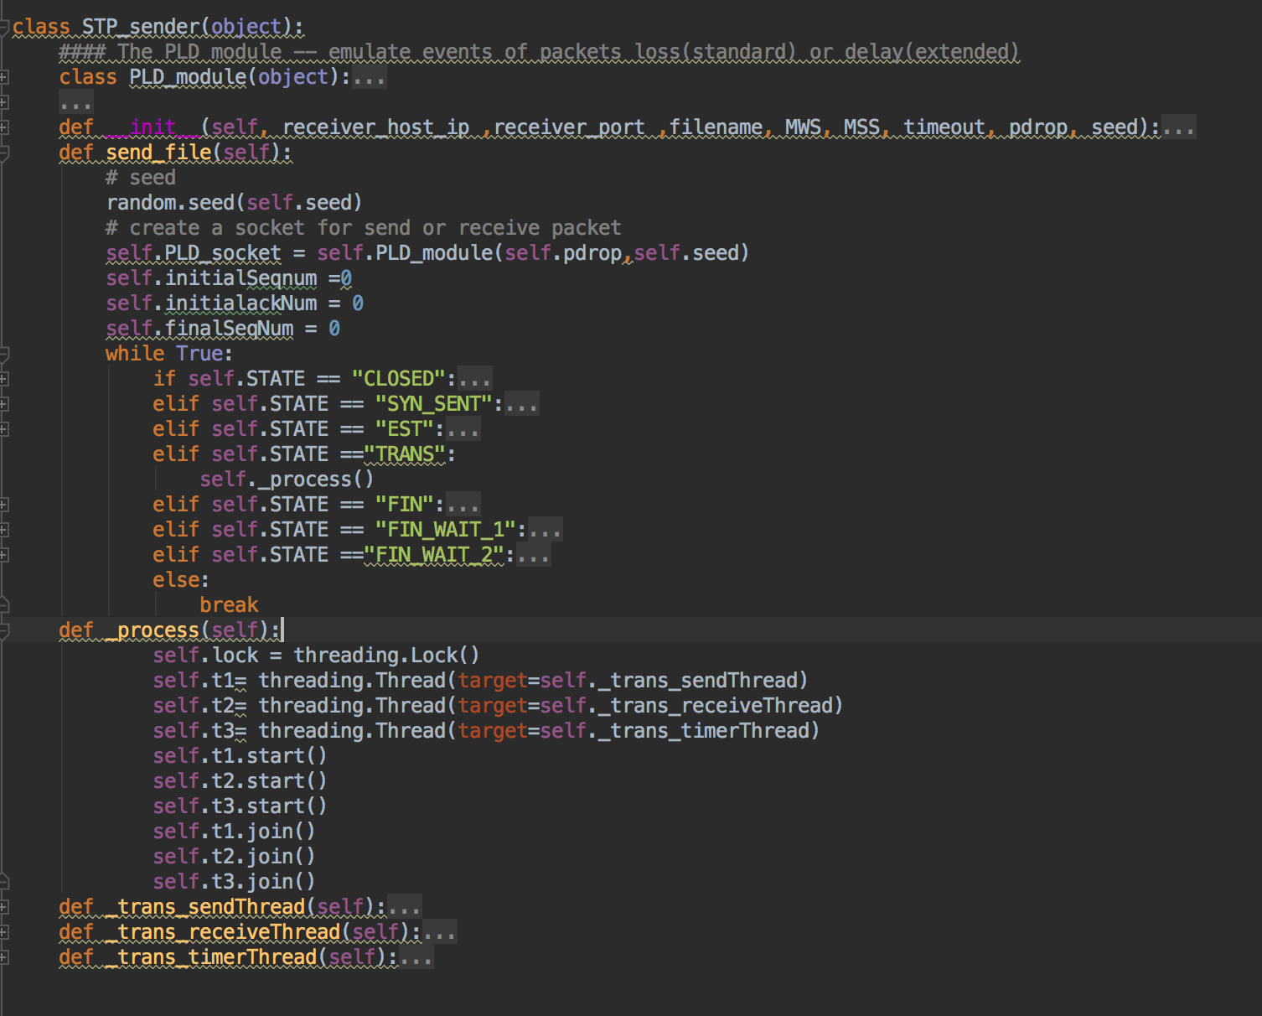

For sending file, we use while loop to model an infinite state machine from three ways handshake state to transmit data state, final with termination state.

In transmission process, we use multi process to do send, receive, timeout separately.

Receiver.py

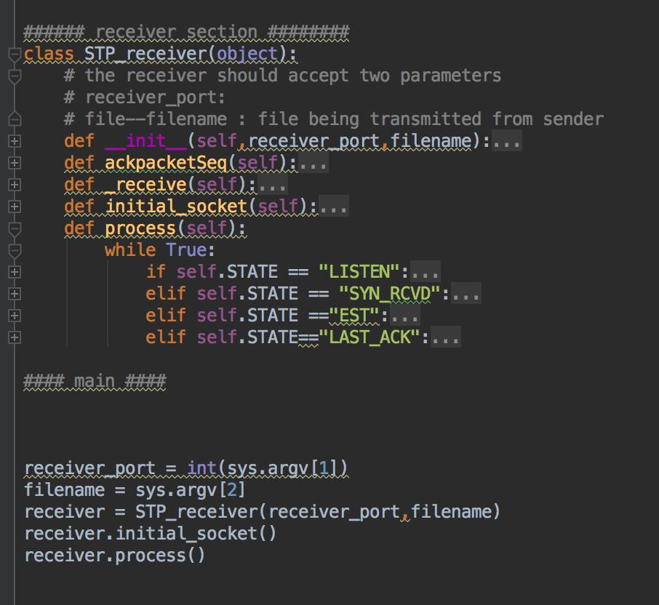

same as sender.py, a simple infinite machine to transfer from each state.

**2.Diagram of STP header and explanation**

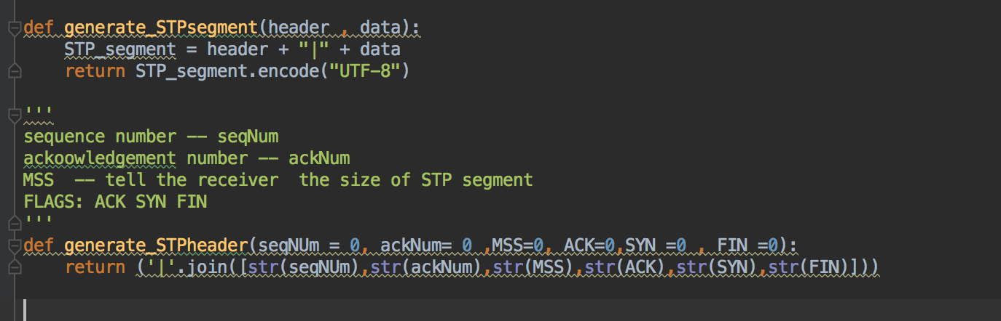

STP header

|  |  |
| --- | --- |
| #seq_num | #ack_num |
| ACK | SYN |
| FIN | MSS |
| Data | |

**3. Question**

(a)

set timeout as 10MS

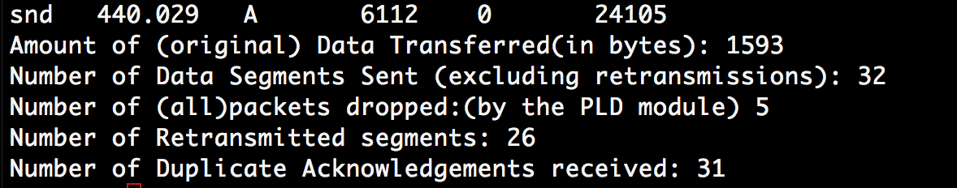

Due to lower timeout, the STP protocol will easily trigger the timeout module to cause a mass of unnecessary Retransmissions.

Set time out as 30MS, 50MS, 100ms

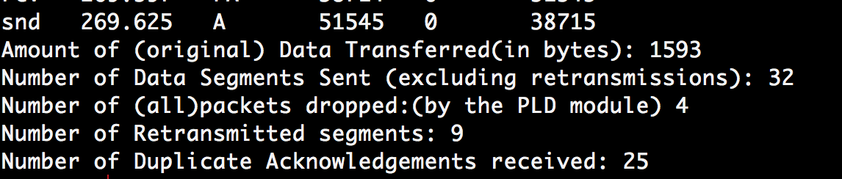

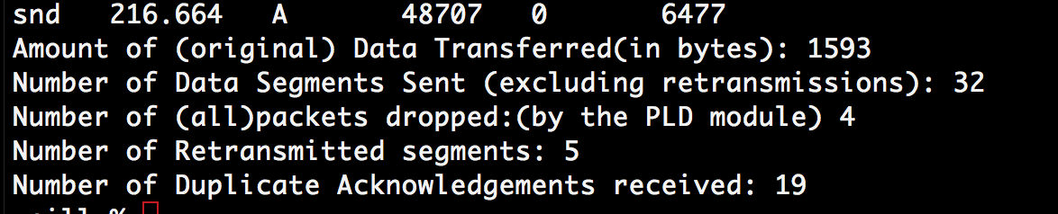

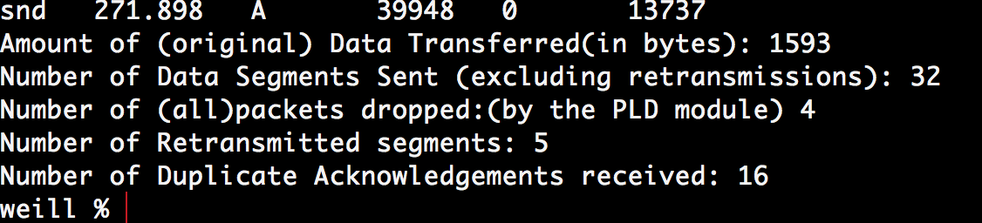

When the value of timeout increased as 50MS, the number of Retransmission turns reasonable. So we set timeout as 50MS for test.

With the timeout set as 50 MS:

Pdrop = 0.1:

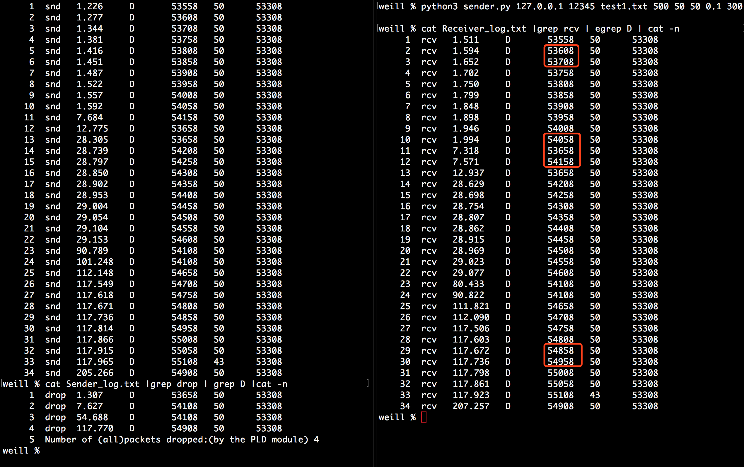

pdrop = 0.3

#53658 – 53708, $ 54108 – 54158, # 54908 – 54958 dropped

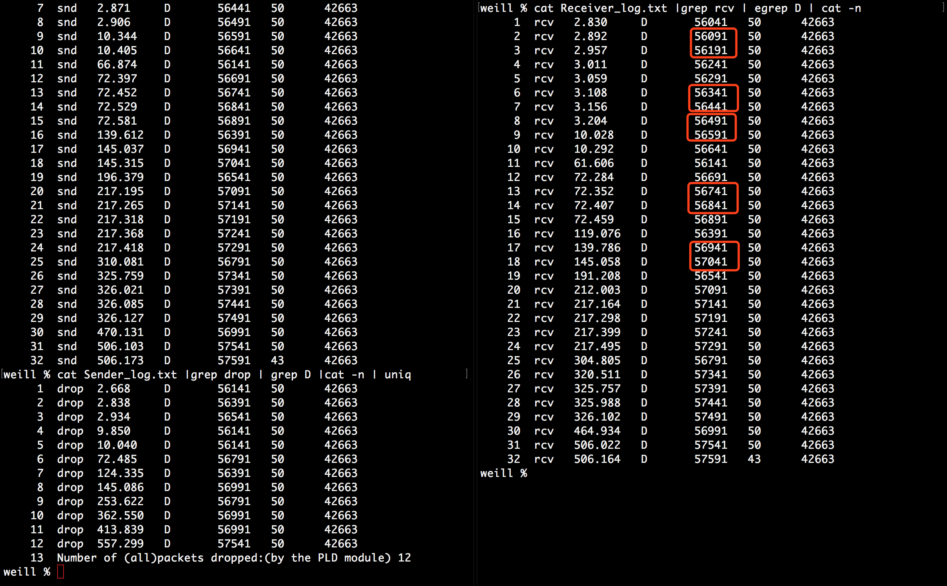

# 56141 -56191 # 56391 -56441 # 56551 -56591 # 56791 – 56841 # 56991-57041 dropped

(b)

|  |  |  |  |
| --- | --- | --- | --- |
|  | 50ms | 200ms | 12ms |
| NumOfTransmitted packets | 46 | 45 | 60 |
| Time cost | 214.308 | 136.768 | 250.625 |

When timeout set as 12ms, it causes lots of Retransmission works. The reason is that: the program could easily trigger the single timer and result in timeout. When the timeout increased from 12 ms to 200 ms, the retransmission work could not mainly produce by timeout instead of fast retransmission. So most of dropped packets will be retransmitted by fast transmission function.